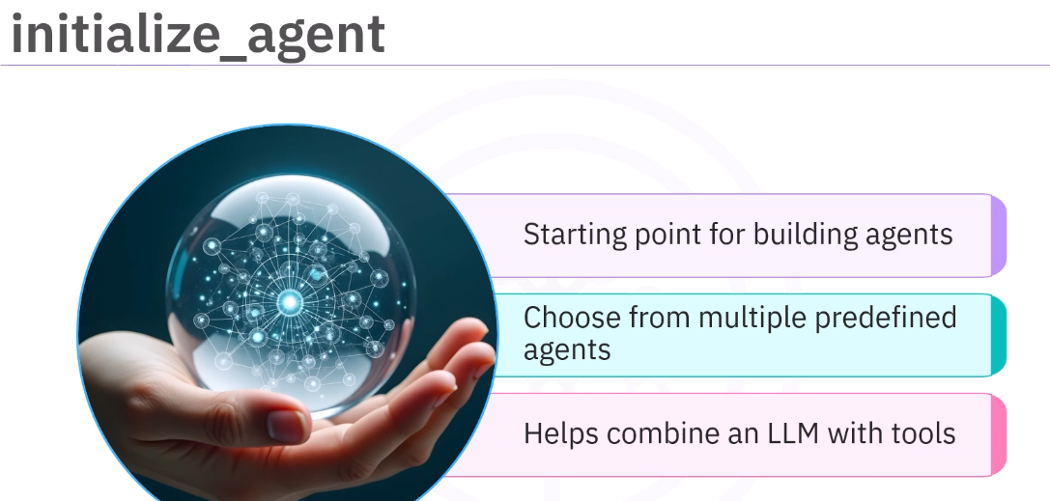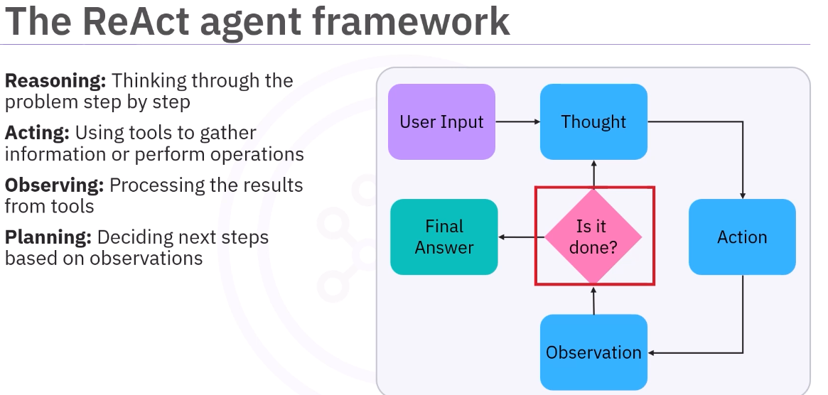 ReAct – Reasaon and Act
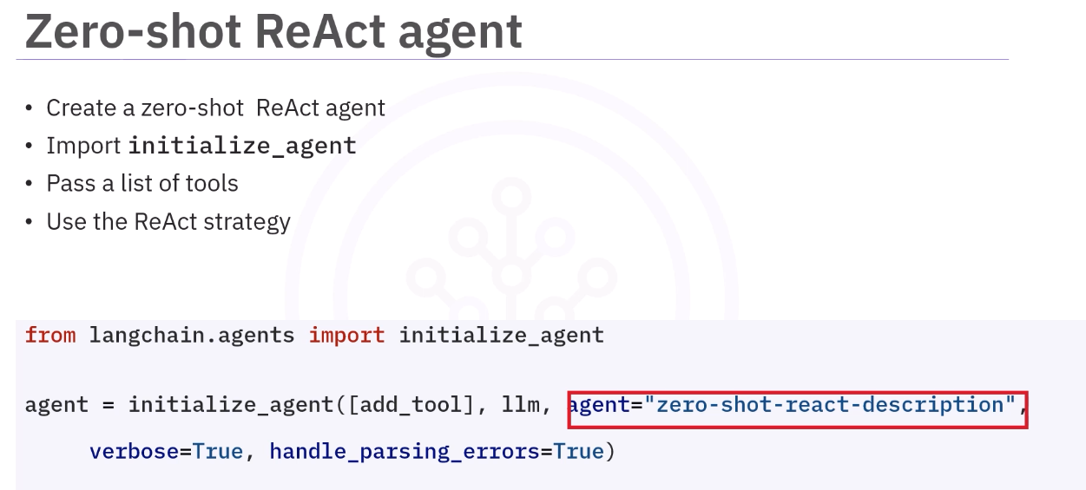

🔥 What this line is doing
👉 You are creating an agent that:
- Has access to tools (add_tool)
- Uses an LLM (llm)
- Follows a specific strategy → "zero-shot-react-description"

🔹 Break each part

✅ [add_tool]
- List of tools you created
- Agent can choose from these

✅ llm
- The brain (GPT, etc.)
- Does reasoning

🔥 ✅ agent="zero-shot-react-description" (MOST IMPORTANT)
This tells LangChain:
“Use the ReAct pattern WITHOUT any training examples — just tool descriptions”

🔹 What does “zero-shot” mean?
No examples given beforehand
The LLM figures out:
- When to use tool
- How to use tool
👉 Only based on:
- Tool description
- User input

🔹 What does “ReAct-description” mean?
It uses:
Reason (think) + Act (call tool)
And uses tool descriptions to decide actions

